

Astana IT University

WEB-Technologies

Big Data Analysis Department

Final project

Creating Web-site

Prepared by: Galamat Sadr

Akhanov Askar

Checked by: Dana Yespenbetova

Nur-Sultan 2021

Hololive is a virtual YouTuber (VTuber) talent agency owned by Japanese tech entertainment company Cover Corporation. Purpose of my website is demonstrating all members of Hololive, offering official merchandise and contacts to ordinary user that could subscribe to their channels and generate income.
The website contains such tables, as:
- Header
- Footer
- Card template
- Body template
- Loading screen
- Carousel

Figure 1 shows header’s appearance:
Figure 1

Figure 2 shows footer’s appearance:
Figure 2

Figure 3 shows card template:
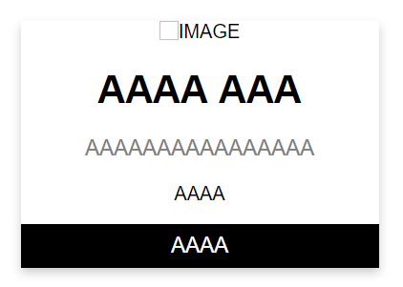
Figure 3

Figure 4 shows template of loading screen:

Figure 4
Figure 5 shows template of carousel:
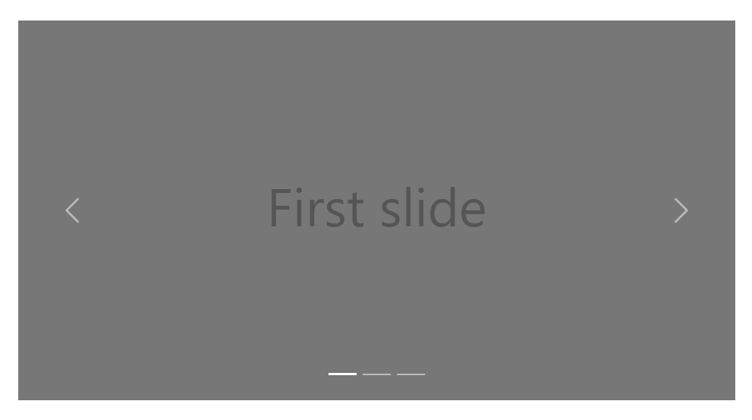
Figure 5

Overall, this project covered all of the topics that we studied in the WEB-Technologies course of 2nd trimester of first year. JQuery, Bootstrap, CSS and HTML were used, however, project could be improved by implementing feedback element in the home page or extending official goods list.

Appendix
1)
HTML
<nav class="top_nav">
<logo> <a href="index.html"><img src="logo.png" alt="" height="45px"></a> </logo>

<button id="hamburger"><i class="fas fa-bars"></i></button>

<ul id="nav_links">
<li><a href="holojp.html">Hololive JP</a></li>
<li><a href="holoen.html">Hololive EN</a></li>
<li><a href="holoid.html">Hololive ID</a></li>
<li><a href="contacts.html">Contacts</a></li>
<li><a href="goods.html">Official Goods</a></li>
<li><a href="https://schedule.hololive.tv">Stream Schedule</a></li>
</ul>
</nav>
CSS
* {
margin: 0;
padding: 0;
border: none;
}
.top_nav {
height: 50px; /* Give navbar fixed height */
background-color: white;
z-index: 2;
}
#nav_links {
display: none;
padding: 10px;
}
#nav_links li a {
/* Remove underlines from links */
font-family: Comic Sans MS, sans-serif;
text-decoration: none;
color: black;
font-size: 15px;
}
#nav_links li a:hover {
color: #2eb6dc;
}
#hamburger {
width: 30px;
height: 30px;
float: right;
margin: 10px;
font-size: 20px;
border-radius: 4px;
}
@media screen and (min-width: 720px) {
.top_nav {
display: grid;
grid-template-columns: 1fr 1fr 2fr;
color: blue;
}
#nav_links {
position: absolute;
top: 50px;
width: 130%;
}

}
@media screen and (min-width: 1515px) {
.top_nav {
display: grid;
grid-template-columns: 1fr 4fr 2fr;
}
#hamburger {
display: none;
}
#nav_links {
display: block;
position: relative;
top: 0;
width: 80%;
height: 30px;
}
#nav_links li {
display: inline;
margin-right: 20px;
}
#nav_links li a:hover {
border-bottom: 1px solid white;
}
}

2)
HTML
<footer>©2021 Sadr Galamat, Astana IT University Copyright</footer>
CSS
footer {
font-family: Arial, Helvetica, sans-serif;
text-align: center;
vertical-align: middle;
width: 100%;
}

3)
HTML
<div class="card">
<img src="https://cs11.pikabu.ru/post_img/big/2020/10/29/2/1603935246125373482.png" alt="Amelia Watson" style="width:100%; height: 400px;">
<h1>Watson Amelia Birthday 2021</h1>
<p class="price">¥2,000</p>
<p>Complete pack of commemorative voices and goods as toys and figures.</p>
<a href="https://shop.geekjack.net/products/amelia-watson-birthday-2021-commemorative-voice-goods-complete-packのコピー-1?_pos=2&_sid=5bc3f79b9&_ss=r"><button>Buy</button></a>
</div>
CSS
.card {
box-shadow: 0 4px 8px 0 rgba(0, 0, 0, 0.2);
max-width: 300px;
margin: auto;
text-align: center;
font-family: arial;
}

.price {
color: grey;
font-size: 22px;
}

.card button {
border: none;
outline: 0;
padding: 12px;
color: white;
background-color: #000;
text-align: center;
cursor: pointer;
width: 100%;
font-size: 18px;
}

.card button:hover {
opacity: 0.7;
}
4)
CSS
.page-loader {
position: fixed;
top: 0;
left: 0;
right: 0;
bottom: 0;
min-height: 100vh;
background-color: #2c2c2c;
z-index: 1900;
}
.light-theme .page-loader {
background: #fff;
}
.page-loader .loader {
display: block;
position: relative;
left: 50%;
top: 50%;
width: 100px;
height: 100px;
margin: -50px 0 0 -50px;
border-radius: 50%;
border: 2px solid transparent;
border-top-color: #c82ef3;
-webkit-animation: spin 2s linear infinite;
animation: spin 2s linear infinite;
}
.page-loader .loader:before {
content: "";
position: absolute;
top: 5px;
left: 5px;
right: 5px;
bottom: 5px;
border-radius: 50%;
border: 2px solid transparent;
border-top-color: #c82ef3;
-webkit-animation: spin 3s linear infinite;
animation: spin 3s linear infinite;
}
.page-loader .loader:after {
content: "";
position: absolute;
top: 15px;
left: 15px;
right: 15px;
bottom: 15px;
border-radius: 50%;
border: 2px solid transparent;
border-top-color: #c82ef3;
-webkit-animation: spin 1.5s linear infinite;
animation: spin 1.5s linear infinite;
}

References
https://www.w3schools.com
https://stackoverflow.com
https://en.hololive.tv

